Press Release

# **Accra’s Luxury Five-Star Hotel to Open New Asian-Fusion Restaurant and Bar**

*Kempinski Hotel Gold Coast City Accra to Open the ASANA Bar and Kitchen in April 2025*

*Accra, 10 April 2025 –* The lobby of Ghana’s only five-star luxury hotel is set to impress with the opening of a new bar and à la carte restaurant in April 2025. The ASANA Bar and Kitchen, situated in the right wing of the expansive lobby at Kempinski Hotel Gold Coast City Accra, will invite guests to savour a taste of Asian-inspired cuisine, crafted with the finest local ingredients for a truly indulgent dining experience.

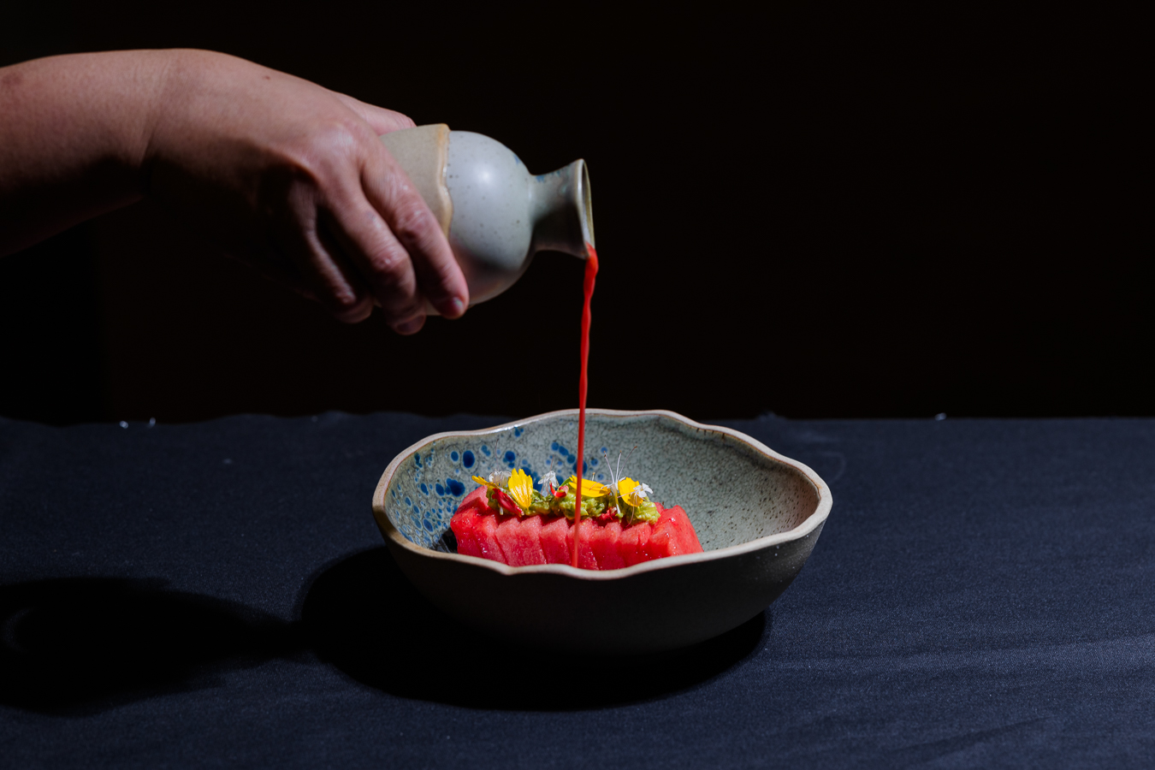

Positioned as a signature bar and all-day dining à la carte restaurant, ASANA will offer flexible seating, allowing guests to enjoy carefully crafted cocktails by seasoned mixologists at the bar and exciting Asian-fusion-inspired dishes from the restaurant. With indoor and outdoor seating options available, the space is perfectly designed to enhance the guests’ dining experience throughout the day.

The bar takes centre stage with its luxurious design elements complemented by the lobby’s striking crystal chandeliers suspended above the water fountain. Its polished finish highlights the deep textures and colours of the marble countertops and will be a key feature reflecting the timeless elegance for which this hotel is known. Designed to elevate the guests’ experience, the elegant bar will offer a 360-degree seating option around its pristine marble counter that will enable guests to enjoy it up close while the creativity and flair of our seasoned mixologists are at their best. Fusion-inspired signature cocktails, wines, spirits and other beverages will provide a curated menu selection suited for different tastes.

‘It is wonderful to see our vision for the ASANA Bar and Kitchen finally coming together,’ said Felix Otte, Director of Food and Beverage. ‘It is a refreshing new dining concept that puts a spotlight on our desire to showcase even more creativity in our food and beverage offerings.’

‘Kempinski originally started off as a restaurant business, and over the years, we have been intentional in our efforts to enhance the overall dining experience for our guests at the hotel. I’m confident that ASANA will not only be a venue with great music and a wonderful ambience but will also be a place for curious palates to savour unique, locally inspired Asian fusion cuisine,’ he said.

A little over a year ago, General Manager Mr. Hanno Barkhoff hinted at the ambitious food and beverage concepts the five-star luxury hotel had in place to elevate the dining experiences of guests. Now, a year later, his dream is set to become a reality as the hotel looks to mark its 10-year anniversary, celebrating a decade of luxury, innovation and service excellence in Ghana.

‘We are delighted with this addition to our dining outlets, and it is exciting to know that our guests will embark on a new gourmet journey with us,’ he said. ‘Ghanaian cuisine is known for its bold flavours and vibrant colours, and with Chef Shara Tumaob adding a touch of Asian flair to our menu, we are sure to have the best of both worlds.’

‘Our lobby plays a significant role in our guests’ journey and, in many ways, symbolically reflects the high standards of luxury and hospitality that our guests deserve. Having this new bar and restaurant situated at the very heart of our hotel will give us the opportunity to set the tone for an exciting adventure with Kempinski every time our guests walk through our doors.’

**-ENDS-**

**About Kempinski Hotel Gold Coast City Accra:** [Kempinski Hotel Gold Coast City Accra](http://www.kempinski.com/accra) is a luxury lifestyle destination that has been designed to offer the highest standards of European luxury with the remarkable warmth and hospitality for which Ghanaians are renowned. Kempinski offers 269 rooms, including luxury suites and presidential suites. The hotel is located in the downtown area in close proximity to the State House, the Accra International Conference Centre and the National Theatre.

**About Kempinski:** Created in 1897, Kempinski Hotels is Europe’s oldest luxury hotel group. Kempinski’s rich heritage of impeccable personal service and superb hospitality is complemented by the exclusivity and individuality of its properties. Today the Kempinski Group operates 78 hotels and residences in 32 countries and currently has more than 31 prestigious projects under development around the globe. Each five-star hotel reflects the strength and success of the Kempinski brand without losing sight of its heritage; each one imbues the quality guests have come to expect from Kempinski while embracing the cultural traditions of its location. The portfolio comprises historic landmark properties, award-winning urban lifestyle hotels, outstanding resorts and prestigious residences. Kempinski is a founding member of the Global Hotel Alliance (GHA), the world’s largest alliance of independent hotel brands. [www.kempinski.com](http://www.kempinski.com) [www.ghadiscovery.com](http://www.ghadiscovery.com).

**Media contacts:**

Theodora M. Yebuah · Assistant Marketing Manager

Kempinski Hotel Gold Coast City Accra

PMB 66 - Ministries · Gamel Abdul Nasser Avenue, Ridge · Accra · Ghana

T +233 24 243 6000 · [theodora.yebuah@kempinski.com](mailto:theodora.yebuah@kempinski.com)